Assignment 2
Name : Dharm Soni
PRN : 202501090152
Course : Essential of Data Science
Faculty : Mrs. Suvidha Shah

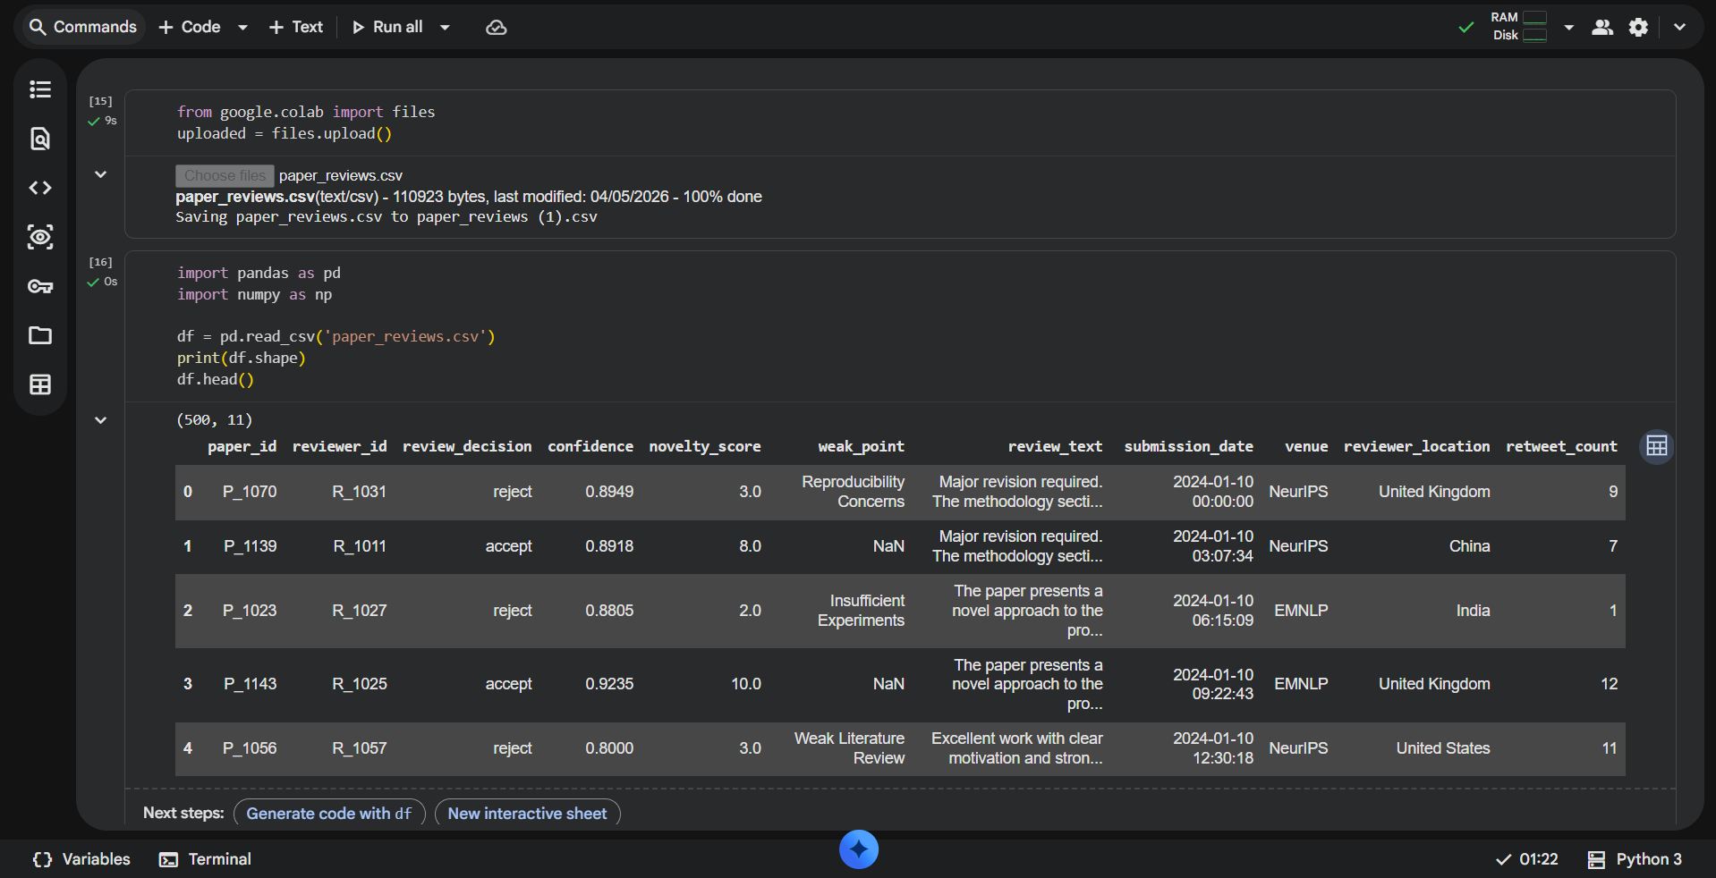

Problem 1:
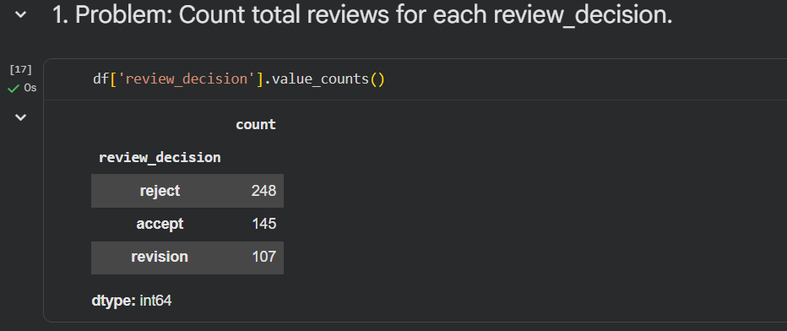

Problem 2:
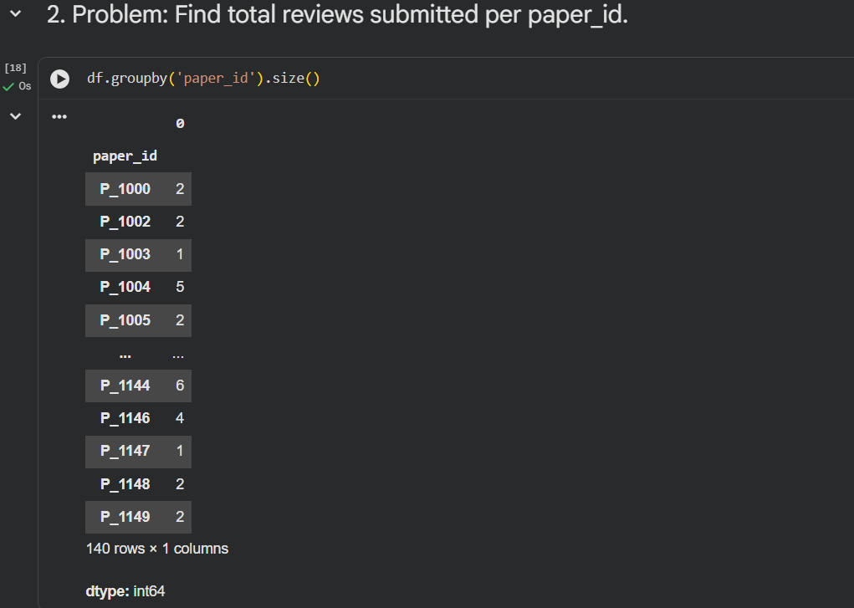
Problem 3:
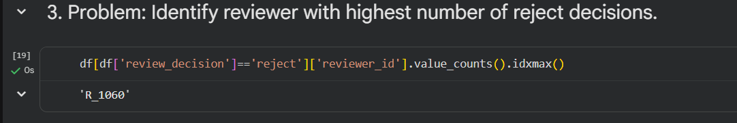
Problem 4:
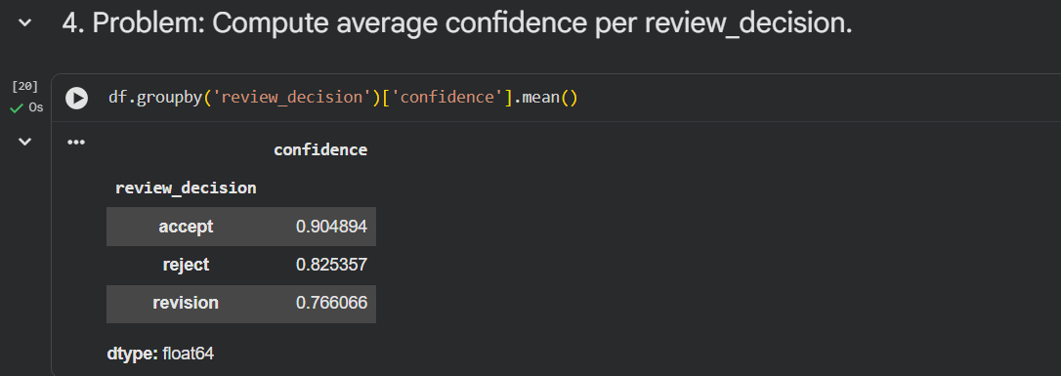

Problem 5:

Problem 6:

Problem 7:
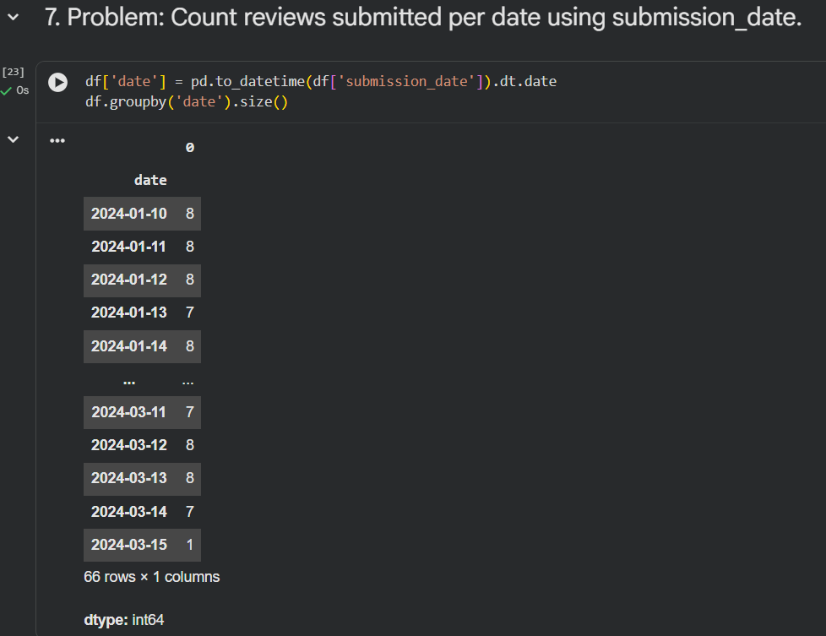

Problem 8:
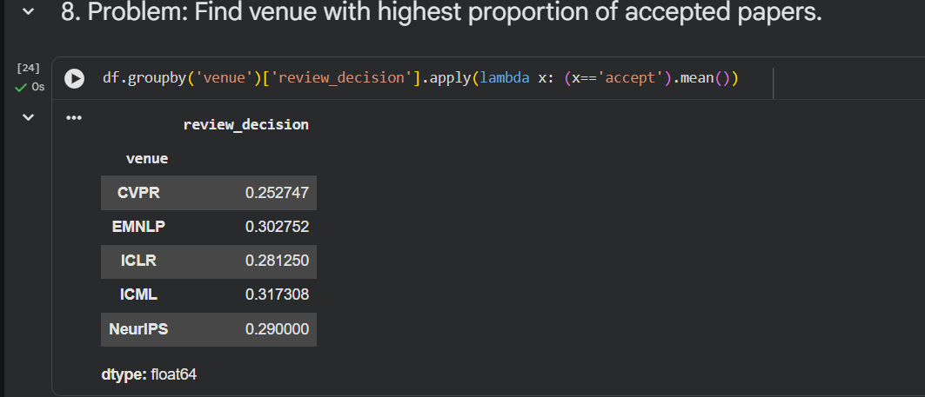
Problem 9:
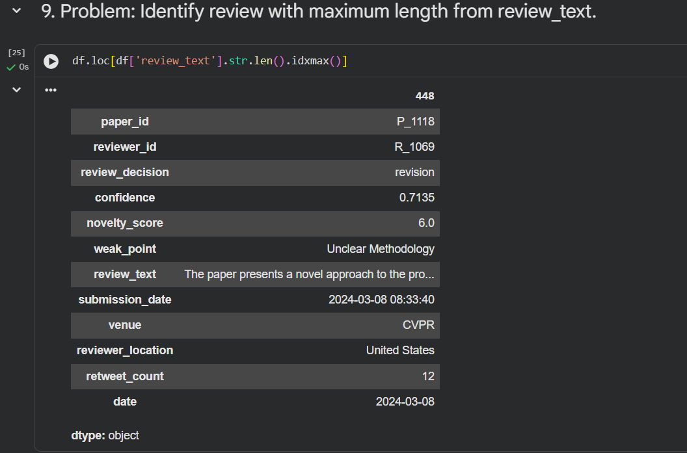

Problem 10:
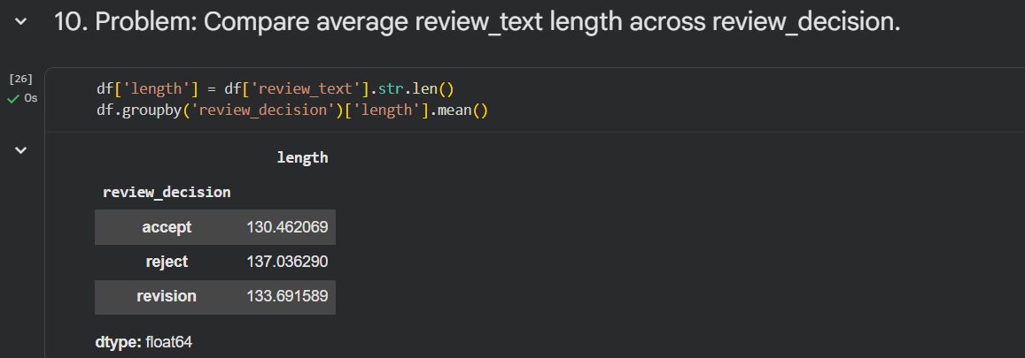
Problem 11:
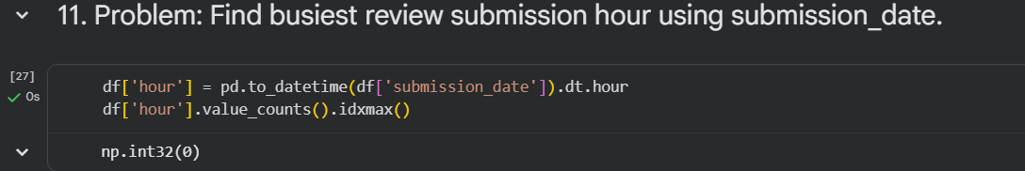
Problem 12:
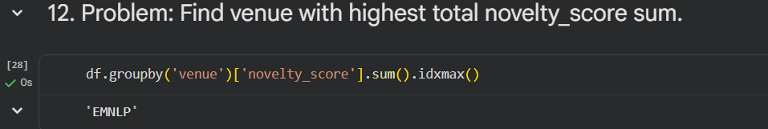
Problem 13:
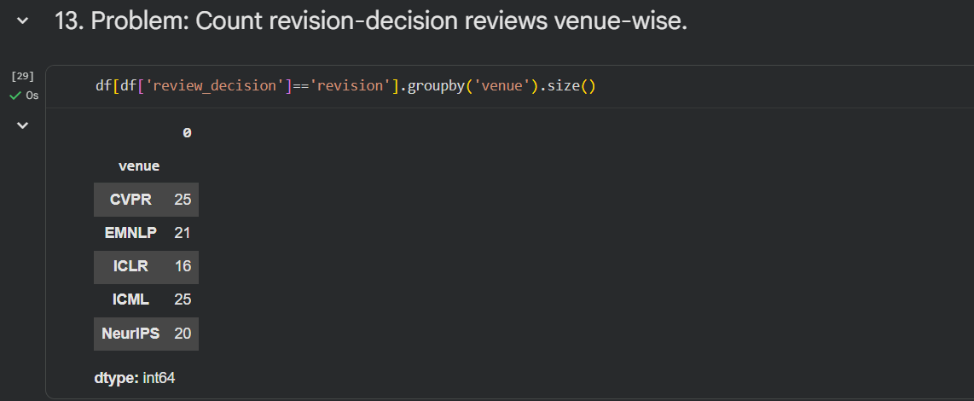

Problem 14:
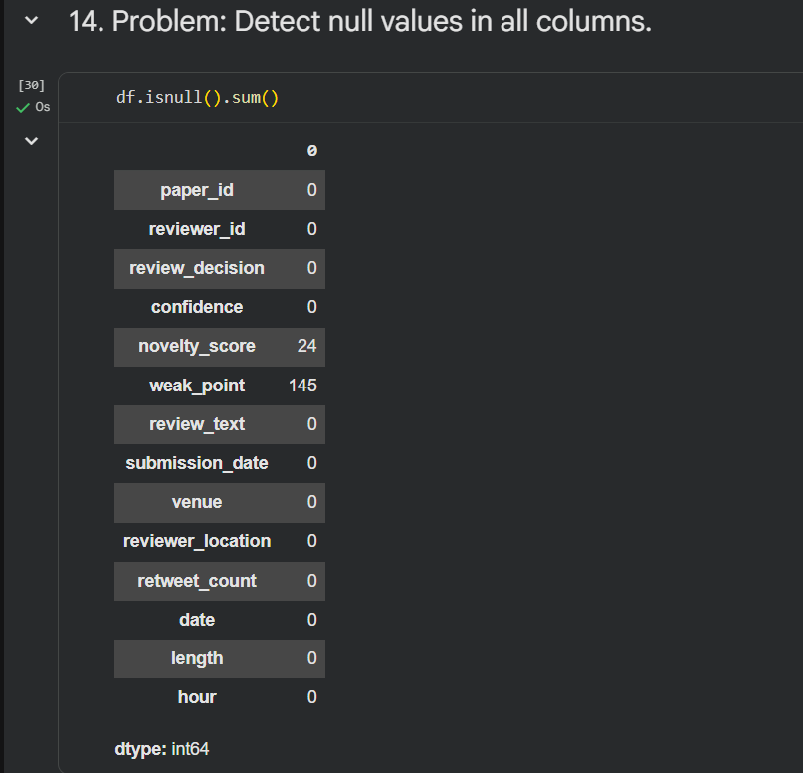
Problem 15:
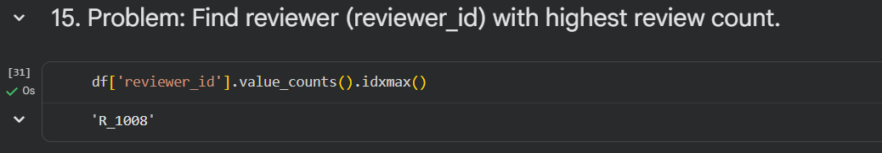

Problem 16:
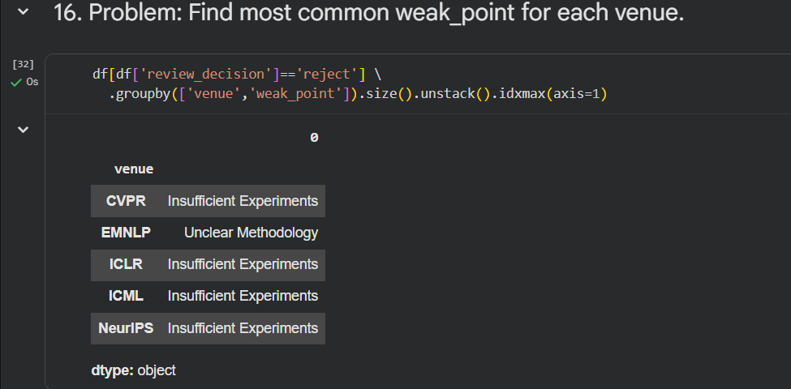
Problem 17:
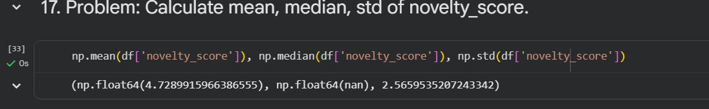
Problem 18:
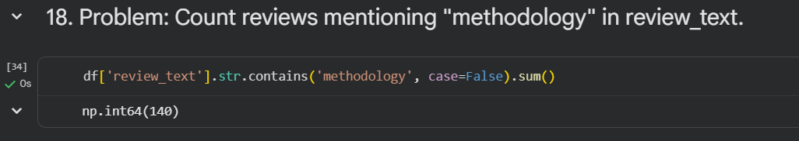

Problem 19:
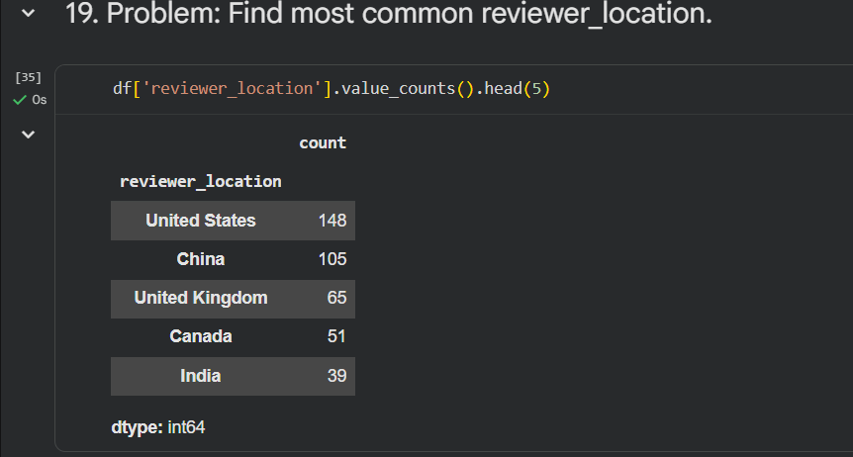
Problem 20:
